Experiment-3-Car Booking System
Aim:
To develop a SaaS-based car rental system to manage car details and booking operations.
Procedure:
- Created Cars and Customers forms to store details.
- A Booking form was developed using lookup fields to connect customers and cars.
- Fields like booking date, return date, and status were added.
- Sample data was entered and booking was performed.
- Output was verified in reports.

Output:
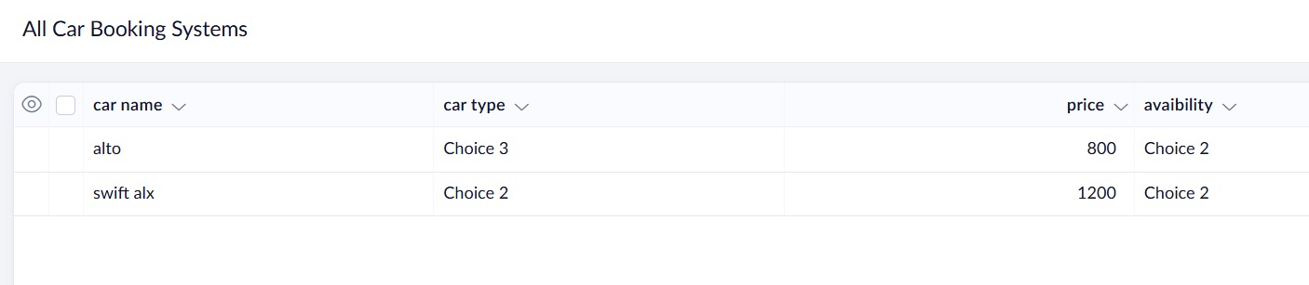

Result:
Car booking system successfully manages rental data and displays it in table format.

